

ANNUAL REPORT   
2021  
LIBRARY AND INFORMATION SERVICES

|  |  |  |
| --- | --- | --- |
|  |  |  |
|  |  |  |
|  |  |  |
|  |  |  |
|  |  |  |

Contents

1. Our Vision and Mission 3

2. Acknowledgements 4

3. Introduction 5

4. Director: Library and Information Services 5

5. LIS ACHIEVEMENTS 6

6. LIS V2030 STRATEGIC PLANNING SESSION 7

7. Staff Development 8

8. User Profile and USer Access: Statistics Summary 11

9. Service Profile 13

Circulation Services 13

Information and Training services 17

Bibliographic Services 22

Library and Information Systems and Digital Applications Department 35

10. Library Financial Statements 38

# Our Vision and Mission

**Vision:**

In pursuance of the Nelson Mandela University vision in becoming a dynamic African University that provides cutting edge knowledge for a sustainable future, Nelson Mandela University LIS aspires to be the global leading academic library and information service that is recognised as an innovative, creative and accessible partner in advancing the teaching, learning, research and engagement goals of the University.

To achieve our vision, we must be characterised by:

* Well-resourced campus libraries
* A people-centered quality services
* Competent, value-driven and professional staff
* New technologies and methods to enhance access to information resources
* Organisational effectiveness and sustainable financial strength
* Access to global and digital information resources

**Mission:**

Our Mission is to facilitate access to quality information resources and services for excellence in research, teaching and learning and to provide physical and virtual spaces to our Users by:

* Providing an environment in which users of all abilities and backgrounds feel welcome and secure
* Identifying, evaluating and satisfying the information needs of our users
* Structuring systems and developing gateways to provide prompt, integrated, convenient and user-friendly access to resources enabling us to meet our service delivery objectives
* Partnering with users to ensure that they become skilled in discovering and using information
* Participating in cooperative and collaborative programmes with other institutions to enhance resources provided and services offered
* Providing access to high-quality scholarly information resources, user-focused services, physical and online spaces
* Providing pathways to enrich learning and research experiences enabling engagement with the university and the wider community
* Striving to broaden and deepen users’ interactions with existing and emerging information eco-systems
* Supporting excellent scholarship via library spaces, online access, supply of printed library material, multimedia and networked devices.
* Discoverability and accessibility of intellectual outputs to the world

**OUR VALUES:**

* Respect for Diversity
* Excellence
* Social Justice and equality
* Ubuntu
* Integrity
* Diversity
* Sustainable stewardship

# Acknowledgements

A special thanks to Deputy Vice-Chancellor: Research, Innovation and Internationalisation: Dr Thandi Mgwebi for her unwavering support to the Library and Information Services during 2021.

Thanks to the Senate Library Committee (LISC) members for their constructive and valuable, input, engagement, and advice on essential Library matters.

The LIS Directorate is acknowledged for the leadership of its sub- directorates and staff and for building external relations with Library Users and the University Leadership.

All other Library Staff at all the Campus Libraries, permanent and contract, for their hard work and loyalty to the Library and Information Services (LIS) in rendering Library services and support, physically and virtually, during these challenging times of the Covid 19 pandemic.

# Introduction

2021 continued to dominate the way we live with various new strains of the Coronavirus. The continuation of lockdown levels made it difficult for most students to visit campus libraries. For the larger part of the year, the restrictions prevented students from coming onto campus. Library operations were much smoother and improved compared to 2020, although we still operated under stringent measures as we had to adhere to Covid 19 regulations. Below challenges had persisted into 2021 physical operations of our campus libraries: The Library and Information Services (LIS) activities are reflected in the 2021 annual report and cover opportunities and challenges faced during the 2021 academic year. LIS continued to emphasise information literacy training, knowing your Faculty Librarian, and promoting electronic resources. The LIS offered contact and virtual services to support students on platforms at their convenience in a blended learning environment.

# Director: Library and Information Services

The Director: LIS post has become vacant at the end of 2019 at the retirement of the immediate past Director: LIS, Mr Robert Pearce. Ms Zingisani Nokubonga Makrwede, the Deputy Director: Circulation Services, was appointed as the Acting Library Director from 1 January 2020 until 30 June 2021. New Director: LIS appointment was made from 1 July 2021.  
 **Introduction**

On behalf of the Nelson Mandela University Library and Information Services, it is a great honour that I am presenting a narrative of the Libraries' achievements, highlights, and challenges in 2021. It is a privilege to serve Nelson Mandela University with a team of dedicated colleagues willing to go the extra mile to meet and service Mandela University students and academics.   
  
**HIGHLIGHTS OF THE YEAR**

**Appointment of Director: LIS**

On 1 July 2022, Mr Lindsay Reid got appointed as the Director of Library and Information Services – filling a position that was vacant for almost two years.



# LIS ACHIEVEMENTS

**VC AWARDS**

Ms Blondie Ntsiko (LIS) - **Envisioning Engagement and Outreach**

**Emerging Engagement Award**



A team effort with the lead, Ms Ntsiko, lead the LIS to receive the Engagement Team Award as part of the Vice-Chancellor's Excellence Awards of 2020. In acknowledging the team's remarkable achievement in celebrating "Excellence", the Vice-Chancellor's presented Ms Ntsiko with the Vice-Chancellor's Excellence Awards. Excellence is one of the University's six values. The VC believes it is core to achieving the University's vision of Nelson Mandela University as a dynamic African university, recognised for its leadership in generating cutting-edge knowledge for a sustainable future. Congratulations on your outstanding achievement.

**INTER-LIBRARY LOANS:**

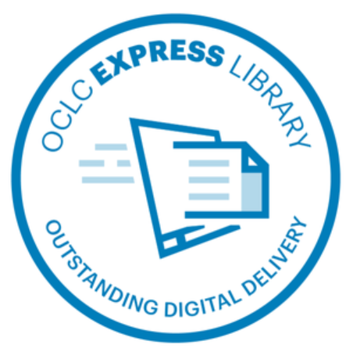

Nelson Mandela University LIS was invited to join an elite group of libraries of the OCLC’s Express digital delivery program. The Express digital delivery program connects high-performing libraries committed to delivering digital resources within 18 hours or less from request. Mandela Library was invited to join the Express program because of the ILL team’s fast turnaround for articles requests. We are proud of the excellent service rendered by our ILL team.

What are the new Express program?

* **The fastest available solution** to provide articles to you users
* **Speedier delivery of electronic resources**
* Included in the WorldShare ILL subscription **at no extra cost**

# LIS V2030 STRATEGIC PLANNING SESSION

In November 2021, the library conducted a two-and-a-half-day strategic planning workshop aligned with the universities Vision 2030 strategy. During these sessions, internal stakeholders like the Institutional Planning office, Deans of Faculties, Dean of Learning and Teaching, Dean of Students, Research Development, Human Resources the Universities CIO were invited to come and share how they see the library as a 21st Century Academic Library in V2030. The 1st day, Monday 22, from 14h00 to 16h30, was devoted to internal stakeholders who presented the future Nelson Mandela University library in Vision 2030. The Tuesday and Wednesday were set aside for the LIS to look at the latest local and international trends, “State of Readiness report in academic libraries” from CHELSA, creating a SWOT analysis. 32 Librarians and seniors were invited to the strategic planning session. All staff from Librarian, Post level up was asked to attend the strategic planning workshop.

In response, the Library and Information Services has developed a five-year strategic plan based on six core focus areas:

* **Learning, teaching and research support**

**Goal 1:** Provide supportive, inclusive and transformative physical and virtual services to support and advance learning, teaching and research

* **Discovery and collections**

**Goal 2:** Ensure stable, accessible and discoverable digital scholarship platforms and disseminate and communicate research outputs

* **Integrated systems and technologies**

**Goal 3:** Deployment of smart and agile next-generation library systems and technologies that are interoperable with other university systems

* **Scholarly communication**

**Goal 4:** Lead institutional initiatives in advancing Scholarly Communication and Open Science initiatives

* **Engagements, collaborations and partnership**

**Goal 5**: Engage and develop collaborations and partnerships at institutional, national, regional and international levels in response and support of the university strategic goals

* **Organisational effectiveness**

**Goal 6:** Create an inclusive and diverse environment that recruits, reskills, values and retains individuals who share common goals

**Enablers**

* Leadership and Management
* Partnerships and Collaborations
* Policy Frameworks, Guidelines and Procedures
* Resources Mobilisation, Management and Organizational Effectiveness
* Learning Organization and Change Management

With these six core areas supported by skilled staff, modern IT infrastructure, collaborative learning and research spaces, collaborations with the faculties and academic support departments and the SEALS Consortia, the library will deliver on its key mandate of being at the centre of the academic project.

**COLLABORATION AND INFORMATION ACCESS**

Partnership with the George Municipal libraries:

The successful partnering with the Nelson Mandela Bay Municipal libraries has needed to propose the same partnering of the George campus library with the George Municipal libraries. Located in the Western Cape province (George campus). The partnering aims to assist students of Nelson Mandela University George campus with convenient access to essential information resources and reliable internet connection (incl. fast WIFI/connection) through the use of local municipal libraries facilities and resources.  This could cut costs of travelling and save time for Nelson Mandela University George campus library users, especially those living off-campus and when the campus library is closed due to unforeseen circumstances. This initiative had started as geared and driven by a pair of Senior Librarians from Gqeberha campuses, who also succeeded in the same type of partnering in the region of Nelson Mandela Bay Municipalities. Five George Local municipality libraries have been visited. The partnering logistics is ongoing between relevant parties in the George local municipality and the Nelson Mandela University, the George campus ICT/Library. Nelson Mandela University students are already receiving priority when visiting these library facilities.

# Staff Development

Training and webinars have been conducted and attended throughout the year to equip staff with skills that will help them give more excellent service to users. The LIS staff are our most valuable asset; therefore, investing in staff development is essential. With the rapid change of the information technology environment, the empowerment and development of staff need constant attention.

**TRAINING/WORKSHOP/WEBINAR**

|  |  |
| --- | --- |
| **Training/Workshop/Webinar** | **Date** |
| Summon demonstration | January 2021 |
| Clinical Key | February 2021 |
| Sabinet Online Journals Training: NMU | February 2021 |
| Webinar – Overview of directory of open access journals | February 2021 |
| LibGuides Demonstration | March 2021 |
| Building a Libguides overview | March 2021 |
| Sage Research Methods | April 2021 |
| Access Global NewsBank Training Session | April 2021 |
| Being Mindful | April 2021 |
| NKODA music database trial | April 2021 |
| Micromedex Training | May 2021 |
| Access to IBM Micromedex Information Session | May 2021 |
| Open access in SA | May 2021 |
| Summon demo to SEALS by Robert Bley | May 2021 |
| Online Training: Strategic Risk Management | May 2021 |
| EndNote Training | June 2021 |
| POPIA Compliance | June 2021 |
| Primal Pictures Training | June 2021 |
| WGSN Explanation lecture | June 2021 |
| Elsevier Health Products Meeting | June 2021 |
| Taylor and Francis | July 2021 |
| Incites | August 2021 |
| Sage Journals/ Research Methods | August 2021 |
| Newsbank | August 2021 |
| Vital Training | August 2021 |
| Effective Conflict Resolution | August 2021 |
| Jove Webinar | August 2021 |
| African Newspaper Series 1 and 2 | August 2021 |
| The African Continent Conference on Digitization | August 2021 |
| The UCT Fires: A digitalization case study | August 2021 |
| SANLiC 2021 Conference | August 2021 |
| Webinar – Publishing in line with sustainable development - Elsevier | September 2021 |
| EBSCO Health Databases | September 2021 |
| ZoomText and Jaws Virtual Training | September 2021 |
| Fair data on 4TU (Figshare) | September 2021 |
| Emerald Publishing Training Webinar | September 2021 |
| Libguide - Using Free Graphics Tools with Springy Products | October 2021 |
| Crucial Conversation | October 2021 |
| McGraw Hill Webinar - An Overview of AccessMedicine | October 2021 |
| Managing Digital Collections: How can libraries make their print and digital collections work together? | October 2021 |
| International Symposium on Robotics and AI in Academic Libraries and the Education Sector | November 2021 |
| 16th Stellenbosch University Library Symposium | November 2021 |

**TEAM PROJECTS CURRENT AND COMPLETED**

|  |  |  |  |
| --- | --- | --- | --- |
| **Project** | **Project Leader/s** | **Team** | **Status** |
| User Experience Survey | D Minnaar | C Mlahleki | Completed |
| Missing Book Search | N Sontsonga | Circulation Staff | Completed |
| Marketing of Information Librarians | Mzoxolo Tame | Information Staff | Completed |
| LibGuides | H van der Sandt | Information Staff | Completed |

**STAFF TURNOVER (Appointments, achievements, resignations & retirements)**

**APPOINTMENTS FOR 2021**

|  |  |  |  |
| --- | --- | --- | --- |
| **Name** | **Post Name** | **Campus** | **Date** |
| Lindsay Reid | Director: LIS | South | 1 July 2021 |

**PROMOTIONS 2021**

|  |  |  |  |
| --- | --- | --- | --- |
| **Name** | **Post Name** | **Campus** | **Date** |
| Luyolo Matabeni | Senior Librarian: Acquisitions | South | 1 June 2021 |
| Cikizwa Mlahleki | Branch Librarian | North | 1 April 2021 |
| Rafiekah Abrahams | Senior Librarian: ERM | South | 1 February 2021 |

**FORMAL STUDIES REGISTERED AND COMPLETED 2021**

|  |  |  |  |
| --- | --- | --- | --- |
| **Name** | **Qualification** | **Campus** | **Status** |
| Kaya Ngcuka | Higher Certificate in Archives from UNISA | Missionvale | Completed |
| Nompiliso Keseni | PGDip Archives and Records Management (UFH) | Missionvale | Registered |
| Tanya Hermanus | Public Administration (Lyceum) | Missionvale | Registered |
| Magdalene Breda | MIT – Stream B (UP) | Missionvale | Registered |
| Lungisile Magoso | Master of Information Science (UNISA) | George | Registered |
| Sandisiwe Langa | Bachelor Information Sc (UNISA) | George | Registered |
| Siya Sirayi | MCOM (Business Management) Research NMU | South | Registered |

**STAFF RESIGNATIONS & RETIREMENTS**

|  |  |  |  |  |
| --- | --- | --- | --- | --- |
| **Name** | **Post Name** | **Campus** | **Date** | **Reason** |
| Pumela Mhlomeli | ERM: Librarian | South | 31 October 2021 | Resigned |
| Xoliswa Matroko | ERM: Librarian | South | 30 September 2021 | Resigned |
| Grace Mlambo | Book processor | South | 31 December 2021 | Retired |

**STAFF BEREAVEMENTS 2021**Siviwe Grootboom, Library Assistant (Information), Missionvale

**VACANT POSITIONS**

|  |  |  |  |  |
| --- | --- | --- | --- | --- |
| **Post Name** | **Post Code** | **Campus Library** | **Status** | **Date** |
| Branch Librarian (PL7) | 2204 | 2nd Avenue | Advertised | 12 February 2021 |
| Senior Librarian: Training (PL 8) | 2187 | South | Advertised | 31 December 2020 |
| Librarian: Information Services | 2206 | North | Advertised | 16 November 2021 |
| Library Assistant: Afterhours | 3280 | Missionvale | Advertised | 16 November 2021 |

# User Profile and USer Access: Statistics Summary

**Registered users**

|  |  |  |  |
| --- | --- | --- | --- |
| **Patron Type** | **2019** | **2020** | **2021** |
| 1st - 3rd year | 12496 | 23234 | 27282 |
| 4th - 5th year | 2326 | 5812 | 7053 |
| M & D students | 2644 | 3400 | 3090 |
| International students | 836 | 911 | 1140 |
| Leadership Academy Students | 28 | 1 | 3 |
| Inter-loans | 0 | 365 | 112 |
| Academic & Research | 802 | 818 | 822 |
| Admin & Tech Staff | 454 | 461 | 443 |
| External Users - Academic | 44 | 26 | 4 |
| External Users - Firms | 1 | 2 | 0 |
| External Users - General | 37 | 22 | 3 |
| External Users -Honorary | 13 | 13 | 8 |
| LIS Staff | 88 | 87 | 85 |
| Block Loans | 27 | 24 | 26 |
| **Total** | **19796** | **35176** | **40071** |

**Registered users per Campus**

|  |  |  |  |
| --- | --- | --- | --- |
| **Campus** | **2019** | **2020** | **2021** |
| South Campus | 8979 | 15285 | 17424 |
| North Campus | 3541 | 7263 | 7877 |
| 2nd Avenue Campus | 2747 | 5510 | 6873 |
| Missionvale Campus | 1720 | 3136 | 3442 |
| George Campus | 1319 | 2035 | 2797 |
| Business School | 233 | 203 | 155 |
| **Total** | **18539** | **33432** | **38568** |

**Registered users per Faculty**

|  |  |  |  |
| --- | --- | --- | --- |
| **Faculty** | **2019** | **2020** | **2021** |
| **Humanities** | | | |
| LIS Users | 3569 | 5485 | 5952 |
| Enrolled Students | 4901 | 4652 | 4884 |
| % | **72%** | **117.91%** | **121.87%** |
| **Business & Economic** | | | |
| LIS Users | 5611 | 10260 | 12585 |
| Enrolled Students | 9206 | 9456 | 9902 |
| % | **61%** | **108.5%** | **127.09%** |
| **Education** | | | |
| LIS Users | 1108 | 2759 | 3256 |
| Enrolled Students | 2105 | 2340 | 2313 |
| **%** | **52%** | **117.91%** | **140.77%** |
| **EBEIT** | | | |
| LIS Users | 2587 | 5903 | 6936 |
| Enrolled Students | 5395 | 5525 | 5515 |
| % | **47%** | **106.84%** | **125.77%** |
| **Health Science** | | | |
| LIS Users | 2400 | 3918 | 4065 |
| Enrolled Students | 3550 | 3210 | 3131 |
| % | **67%** | **122.06%** | **129.83%** |
| **Law** | | | |
| LIS Users | 972 | 1627 | 1870 |
| Enrolled Students | 1311 | 1437 | 1450 |
| % | **74%** | **133.22%** | **128.97%** |
| **Science** | | | |
| LIS Users | 1979 | 3306 | 3730 |
| Enrolled Students | 2895 | 2815 | 2903 |
| % | **68%** | **115.96%** | **128.48%** |
| **DVC Research, Innovation & Int** | | | |
| LIS Users | 114 | 112 | 170 |
| Enrolled Students | 224 | 88 | 60 |
| % | **50.89%** | **127.27%** | **283.33%** |
| **Total LIS Users** | **29587** | **33432** | **30158** |

# Service Profile

## Circulation Services

**OPERATIONS ACROSS CAMPUSES**

Extended hours

The library extended its operating hours for the November Examination period from 20 November to 4 December 2021 until 22h00 at night to assist students who need a place to study. During this period, the student assistants also helped screen students entering libraries to comply with the necessary COVID 19 regulations.

Customer Services

2021 came with its challenges, as library users were unable to return overdue books to the library because they were not on campus/not allowed access on campus. Some did not even respond to the requests via email/cell phone calls, / overdue notifications to return outstanding books. The in-person reference interview and the learning commons as a one-stop shop were for most of the year on hold, although the need for these services remains.

**CIRCULATION OF LIBRARY MATERIAL  
  
SHORT LOANS CHECK OUT PER CAMPUS**

|  |  |  |  |
| --- | --- | --- | --- |
| **Campus** | **2019** | **2020** | **2021** |
| South | 25386 | 5095 | 1811 |
| North | 812 | 125 | 275 |
| 2nd | 5453 | 1331 | 459 |
| Missionvale | 347 | 50 | 49 |
| George | 658 | 112 | 363 |
| Business School | 0 | 1 | 0 |
| **Total** | **32656** | **6714** | **2957** |

**STUDY COLLECTION CHECKOUTS PER CAMPUS**

|  |  |  |  |
| --- | --- | --- | --- |
| **Campus** | **2019** | **2020** | **2021** |
| South | 5528 | 1473 | 885 |
| North | 5638 | 1376 | 760 |
| 2nd Ave | 2377 | 583 | 165 |
| Missionvale | 357 | 50 | 37 |
| George | 2351 | 694 | 1042 |
| Business School | 499 | 47 | 22 |
| **Total** | **16750** | **4223** | **2911** |

**CHECKOUTS PER CAMPUS**

|  |  |  |  |
| --- | --- | --- | --- |
| **Campus** | **2019** | **2020** | **2021** |
| South | 76558 | 13285 | 6737 |
| North | 18660 | 3904 | 2822 |
| 2nd Ave | 14946 | 3646 | 1202 |
| Missionvale | 4896 | 900 | 509 |
| George | 32078 | 7681 | 2594 |
| Business School | 1053 | 156 | 97 |
| **Total** | **148191** | **15678** | **13961** |

**CHECKOUTS PER PATRON**

|  |  |  |  |
| --- | --- | --- | --- |
| **P TYPE** | **2019** | **2020** | **2021** |
| 1st – 3rd year | 102712 | 22051 | 7 853 |
| 4th – 5th year | 19715 | 3721 | 1 520 |
| International | 10020 | 1330 | 582 |
| M&D | 7076 | 1786 | 1 036 |
| Acad & Research staff | 3371 | 914 | 1 079 |
| Admin & Tech staff | 1128 | 270 | 239 |
| LIS staff | 1555 | 390 | 606 |
| Distance students | 0 | 0 | 0 |
| Inter-loans | 405 | 96 | 8 |
| Further Education | 0 | 0 | 0 |
| External-Academic | 321 | 26 | 5 |
| External-General | 330 | 76 | 1 |
| External-Firms | 22 | 7 | 0 |
| External-Honorary | 33 | 21 | 36 |
| Block Loans | 1040 | 358 | 936 |
| Leadership Academy | 33 | 2 | 5 |
| **Total** | **147761** | **31048** | **13906** |

**2021 RETURNED BOOKS COLLECTION STATISTICS**

|  |  |
| --- | --- |
| **MONTHS** | **NUMBERS COLLECTED** |
| * JANUARY | * 746 |
| * FEBRUARY | * 835 |
| * MARCH | * 1130 |
| * APRIL | * 1423 |
| * MAY | * 697 |
| * JUNE | * 185 |
| * JULY | * LOCKDOWN |
| * AUGUST | * 677 |
| * SEPTEMBER | * 940 |
| * OCTOBER | * 914 |
| * NOVEMBER | * 1361 |
| * DECEMBER | * 442 |
| **TOTAL** | * **8436** |

**GATE READINGS (LIBRARY VISITS)**

|  |  |
| --- | --- |
| **Campus** | **2021** |
| South | 13673 |
| North | 5251 |
| 2nd Ave | 10996 |
| Missionvale | 10265 |
| George | 19030 |
| Business School | 0 |
| **Total** | 48219 |

**Inter Branch and Inter Library Loans**

|  |  |  |  |
| --- | --- | --- | --- |
| **2021** | **All requests** | **Filled** | **Unfilled** |
| Borrowing - National | 235 | 144 | 11 |
| Lending - National | 877 | 206 | 616 |
| Borrowing - International | 40 | 7 | 33 |
| Lending - International | 121 | 33 | 88 |
| Revenue | $ 515 |  |  |

**FINES COLLECTED ON SIERRA 2021**

|  |  |  |  |  |  |  |
| --- | --- | --- | --- | --- | --- | --- |
| **2021** | **South Campus** | **North Campus** | **Missionvale Campus** | **2nd Avenue** | **Business School** | **George Campus** |
| **FINES** | R5903.00 | R3903.50 | R130.00 | R1374.00 | R0.00 | R1,232.00 |
| **TOTAL:** | R12 542.50 |

## Information and Training services

The Information and Training Services Department consists of Branch, Senior, Faculty and Information Librarians across the six campus libraries as detailed in this report. The Information and Training Services term is used interchangeably with Information Services depending on the preferred name by the institution. The department focuses on information and the management thereof. It includes collecting, organising, and distributing information according to international principles and standards in different education/academic, research, and recreation formats. It also facilitates access to information and training to find and use information effectively for personal and professional purposes.

The Report will cover Learning and Teaching Support and Collection Development and will also highlight the department's role in the virtual presence, capacity building initiatives and visibility, training sessions conducted and recorded reference queries across faculties in various campuses. As blended and hybrid learning and teaching continue at the university, this department renders services to the diverse user community. The team also needs various skills by attending virtual workshops as training and development to provide such services. COVID-19 lockdown measures have led institutions to change how learning, teaching, and research are conducted. The changing landscape calls for skills development to keep abreast with the diverse needs of the users.

**LibGuides Project**

LibGuides - a content management and information sharing system, the platform allows for easy navigation through and instruction on core and relevant resources in a subject field, class, or assignment. The LibGuides project team has been working hard since the platform was acquired.

We are looking forward to transferring the knowledge to equip users to be confident enough to navigate this system independently. We aim to increase the usage of the library's resources and content management systems and ensure that we are moving with the times - digital era.

**Infowise & iLearn**

The Infowise and iLearn website updates have been prepared by the department for ease of access for the users to navigate the information resource tools, e.g. Infowise and iLearn have been effective and efficient in the Training Department detail in the training reports.

**STATIGO SYSTEM: Recorded information queries by Faculty and Patron category**

**STATIGO SYSTEM: Recorded Information Transaction by Campus**

**STATIGO SYSTEM: Recorded Information by Faculty and Transaction Type**

The Information Services team reported that 4409 library-related queries were received by students and staff at the university from the above table. 781 of these queries were Problem Solving queries, and 1733 were Information Reference queries.

#### STATIGO SYSTEM: Campus Library and Contact Type 1 Jan - 31 December 2021

#### STATIGO SYSTEM: Campus Library and Faculty Queries 1 January - 31 December 2021

#### STATIGO SYSTEM: Campus Library and Transaction Type 1 Jan - 31 December 2021

**TRAINING STATISTICS**

**Staff Development: Training taking place on MS Teams - 1 January between 31 December 2021**

The Library Training Department was tasked to assist with staff development during 2021. Staff development was very well attended and appreciated by all information staff since most were conducting online training classes due to the Covid situation.

**eBook and DatabaseTraining: Using MS Teams between 1 January - 31 December 2021**

2021 was the pilot year to have all library training offerings online. The online training sessions were very well attended, apart from all the challenges that staff and students faced. It continued to be a huge success, and students could find information for their assignments. 479 users attended eBook training.

**Library General Information Literacy Training for Undergraduates students using MS Teams between 1 January - 31 December 2021**

Faculty Librarians liaised with the lecturers to continue online training for undergraduate and postgraduate students. Lecturers also felt overwhelmed with the Covid situation and welcomed the library's online training classes.  
 **Library General Information Literacy Training for Postgraduate students using MS Teams between 1 January – 31 December 2021**

There has been a significant uptake of library Training from Postgraduate students then Undergraduate students for library-related training. The Faculty of Education had the largest number of Postgraduate students attending the Library training.

Bibliographic Services  
  
**INFORMATION ASSETS FUND MANAGEMENT, COLLECTION DEVELOPMENT, DISBURSEMENT PER FACULTY, ACCESS TO AND PRESERVATION OF MATERIALS**

This Report is based on Vision 2030 and 2022 Departmental Operational Plans and Milestones of the Nelson Mandela University, Library and Information Services in fulfilling the research, education and training needs of our students and lecturers, ensuring that our Services remain relevant in hybrid print collections, e-Skills and Digitization.

**BUDGET REPORT**

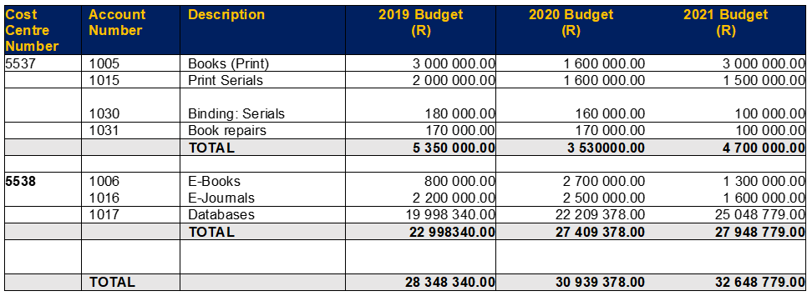

* Budget increase year to year
* 2019 / 2020 increase of ± 9%
* 2020 / 2021 increase of ± 5.6%
* In 2020 an amount of R1 400 000.00 was moved from print books to ebooks due to increased demand for

ebooks because of COVID-19.

* R969 383.00 was moved from print books to ebooks in 2021.
* Rollover for 2019 R169 162.00
* Rollover for 2020 R207 543.00
* No rollover was received for 2021. Although an application of R476 008.00 was submitted with evidence, but no monies were received.

**BUDGET APPROPRIATION & EXPENDITURE**



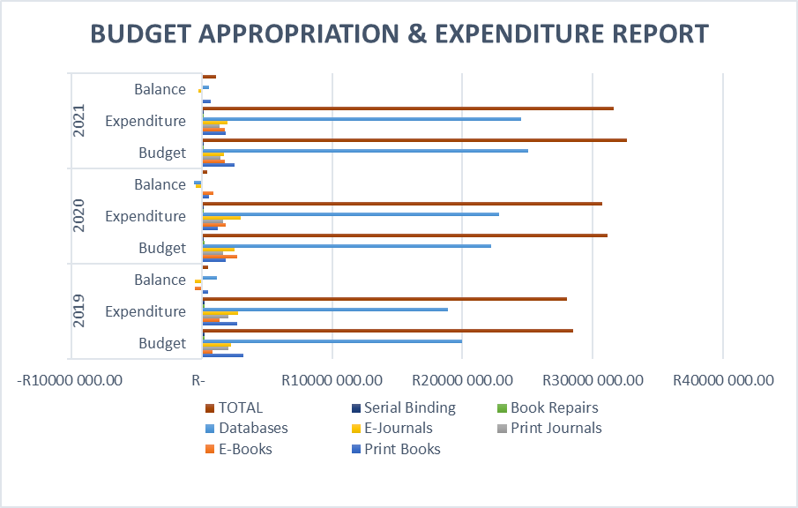

**ACQUISITION DEPARTMENT**



**2021 INFORMATION RESOURCE BUDGET**

In 2021, the COVID-19 pandemic changed the traditional way of working and accessing library material to 100% online access. Both staff and students were affected by working and learning remotely. This change influenced our resource materials to budget significantly. We responded to this change by having a responsive budget approach to serve the need of the library users. Initially, the print book budget was allocated R3 000.000. however, R500 000 was moved to the electronic resources budget at the beginning of 2021, resulting in the print budget having 2 500 000. There was also the movement of funds during the year to serve the needs of resources where they were needed. Move from print to electronic resources. In the budget report, you will note that some of the faculties will not reflect the initial allocation due to these movements of funds. The significant change in the budget serials utilisation is noticeable due to the movement of numerous tittles to the electronic format.

#### BREAKDOWN OF INFORMATION ITEMS



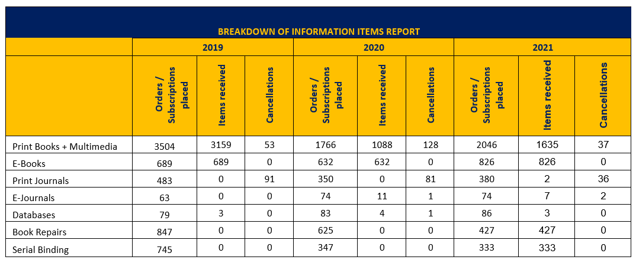

#### VENDOR REPORT – PRINT INFORMATION RESOURCES

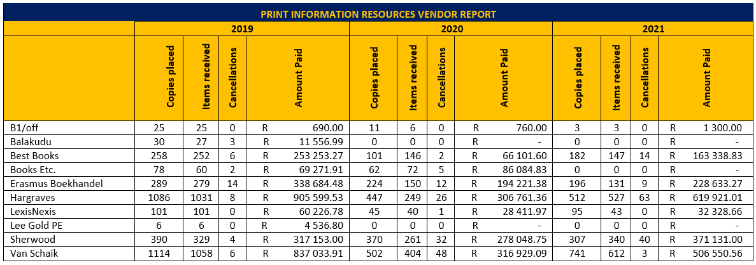

#### ADDITIONAL MONOGRAPH ACTIVITIES

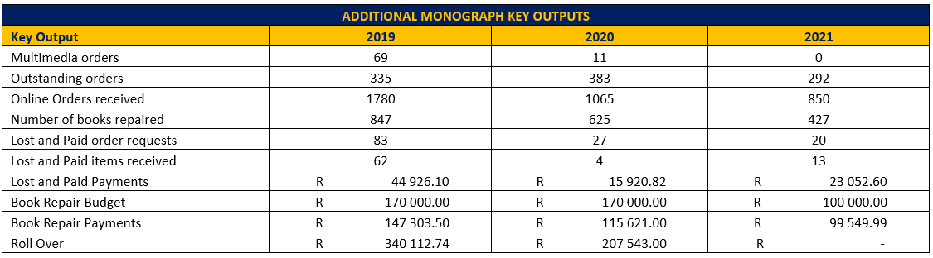

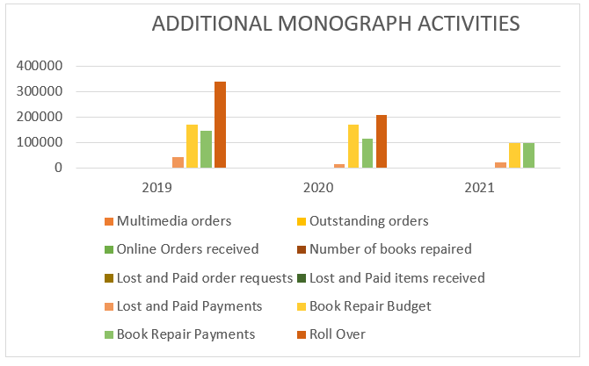

**ELECTRONIC RESOURCE MANAGEMENT**

**BUDGET APPROPRIATION OF E-RESOURCES ACROSS FACULTIES**

#### E-RESOURCES HOLDINGS

|  |  |
| --- | --- |
| **TOTAL NUMBER OF HOLDINGS IN E-RESOURCES** | |
|  | **2021** |
| **Ebooks** | **305470** |
| **E-Journals** | **65248** |
| **Videos** | **1463** |
| **Databases** | **80** |
| **E-Resource Tools** | **8** |

#### SINGLE TITLE EBOOKS PER PUBLISHER OR VENDOR

|  |  |  |
| --- | --- | --- |
| **EBOOK COLLECTION** | **VENDOR** | **NO. OF TITLES** |
| Academic Complete | Proquest | 211050 |
| Proquest | Proquest (single titles) | 299 |
| Cambridge Core | Cambridge | 116 |
| EBSCO E-Book single titles | EBSCO | 2026 |
| VitalSource | Various vendors | 29 |
| SpringerLink | Springer | 66 |
| Wiley | Wiley | 89 |
| Info Science | Info-Science | 2 |
| Juta Law | Juta | 3 |
| Springer Books | Springer | 66 |
| Taylor & Francis Books | Taylor & Francis | 34 |
| ScienceDirect | ScienceDirect | 1 |
| ASM Handbooks | ASM | 39 |
| **TOTAL** |  | **213820** |

**There has been a significant increase in e-resources for 2021 due to the global pandemic. The 213820 are single title e-books with perpetual and subscriptions access models. The rest of the e-books are part of databases packages subscriptions.**

Textbooks / prescribed books are often difficult to find in an e-format. However, we have successfully sourced these on the VitalSource access management platform and directly from publishers. A significant challenge we experienced during the lockdown was providing access to local prescribed textbooks to our users.   Where possible, we would purchase licenses to local textbooks from EBSCO.  However, they do not always offer multiple user licenses, so that we would opt for 3-user licenses in the case of prescribed textbooks. The Problem with purchasing e-textbooks is that the publishers' model is geared toward individual purchases and a library or institutional model is not profitable.  If a title is not available for institutional purchase via any platform, we source the print book.

|  |  |
| --- | --- |
| **SPECIALISED DATABASES PER FACULTY** | |
| **2021** | |
| Humanities | 8 |
| Bus & Econ Sciences | 1 |
| Education | 0 |
| Engineering, Built & Tech. | 8 |
| Health | 10 |
| Law | 11 |
| Sciences | 8 |

#### DATABASES

**NMULIS subscribe to 79 databases of which 8 are online tools and 25 are considered as multidisciplinary.**

|  |  |
| --- | --- |
| * **UPGRADES AND NEW DATABASES FOR 2020 AND 2021** | |
| **Breakdown for 2020** | **Breakdown for 2021** |
| Upgrade LexisNexis to include Practical Guidance | **South African Bureau of Standards (Full Package)** |
| Upgrade WGSN to include Lifestyle & Interiors | **InCites including JCR and ESI** |
| Upgrade JoVE to the ultimate full package | **Oxford Constitutes of the World** |
| Access NewsBank Global 2021 |  |
| ProQuest Academic Core E-Book Collection |  |

#### LICENSE AGREEMENTS

|  |  |
| --- | --- |
| **LICENSE AGREEMENTS** | **NO.** |
| **General License Agreements** | 73 |
| **Terms & Conditions** | 5 |
| **SANLiC Deals** | 24 |
| **Read & Publish Deals** | 5 |
| **Creative Commons License** | 1 |

|  |  |  |
| --- | --- | --- |
| **SANLiC License Agreements** | | |
| **License Agreements** | **PRODUCT** | **NEGOTIATED AGREEMENTS** |
| American Chemical Society | ACS | Completed |
| American Institute of Physics | IOP | Final offer accepted for Read only (2022): 0% (or -1.69% if AAS reduction applies) |
| American Physical Society | APS | Completed |
| American Psychological Association | APA | Completed |
| Cambridge University Press | CUP | Completed |
| Clarivate Analytics | WOS | Completed |
| ClinicalKey | CK Physician, etc. | For the years 2022 to 2026 the increase on ClinicalKey Physician will be 3% per annum. For the other products, the increases are: 2022: 1%, for 2023:2% and for the years 2024-2026: 3% per annum. |
| EBSCOhost | Ultimate package | 3% increase for the year 2022 only for the EBSCO Ultimate package, the other EBSCO not included. |
| Emerald | eJournals Premier, subject collections, case studies | An agreement concluded on a capped R&P offer of • year 1: 2.8%, • Year 2: 2.8% and • Year 3: 2.8% (8.85% cumulative 3-year increase. |
| HeinOnline |  | Completed |
| IEEE Xplore | IEEE Xplore | Signed 13-month offer at 0% |
| Inspec | Inspec | Completed |
| LexisNexis | MyLexisNexis | Completed |
| MathSciNet | MathSciNet | Completed |
| Oxford Law Journals | Oxford Law Journals | Completed |
| Oxford University Press | Oxford journal collection | We have accepted their Online Products three-year offer of 0%, 1%, 1%. Accepted a one-year read-only offer for 2022 collection at an average of 0.9%. |
| ProQuest | Academic Complete | 3% for 2022; 2% for 2023 and 2% for 2024. |
| Royal Society of Chemistry Gold | RSC | Completed |
| SAGE Premier | SAGE Premier | Uncapped Read & Publish (R&P TA) with a 3% annual increase for 3 years on 2021 subscription spend. |
| ScienceDirect | Freedom Collection | Completed |
| SCOAP3 | SCOAP3 | Completed |
| Scopus | Scopus | Completed |
| Springer Nature | SpringerLink | Completed |
| Taylor & Francis | Taylor & Francis SSH & ST | Completed |

**In 2020, NMULIS signed the following "Read and Publish" Agreements for 2021:**

1. A three-year **Cambridge University Press Read & Publish agreement** (1 January 2021 – 31 December 2023) benefits subscribers and non-subscribers alike. CUP no longer offers 'read-only' collections. As of 30 October 2020, CUP revised the annual increase from 2% down to:

* No increase in 2021
* 1.5% increase in 2022
* 3% increase in 2023 (which is effectively 4.54% over three years).

1. The **Royal Society of Chemistry** no longer offers discounts on their collections and individual titles. The General Chemistry Collection was discontinued in 2018. RSC is continuing to offer discounts on the RSC Gold Package.

* The package offer now includes the New Journal Titles package that was previously offered as a separate add-on.
* The package includes allocated APC tokens for publishing in RSC hybrid journals and a 15% discount on article processing charges (APCs). This will enable institutions to publish 50% (calculated on their 2019 output) OA.

**For 2022 the following agreements were signed:**

1. The **Emerald/SANLiC** agreement 2022-2024 is a READ & PUBLISH transformational open access agreement that provides read access to the latest version of your subscriptions as well as permitting eligible corresponding authors to publish a capped number of articles as

open access at no extra charge in the Gold and subscribed hybrid journals to which we subscribe.

The caps (for the consortium as a whole) on the number of articles that can be published at no extra charge for the years of the agreement are:

* 2022 = 111
* 2023 = 134
* 2024 = 158

This works on a first-come-first-serve basis; Emerald will be able to track the number of articles published and will keep SANLiC informed.

1. The **SAGE/SANLiC** agreement for 2022-2024 is for a Read & Publish transitional open access agreement that provides access to the SAGE Premier Collection of over 1100 titles and will also permit eligible corresponding authors to publish an uncapped number of articles as open access in the offered hybrid titles listed in the SAGE/SANLiC agreement. The Gold Open Access Titles: eligible corresponding authors will receive a discount of 20% on SAGE's wholly gold open access portfolio of titles. There are a small number of exclusions where SAGE is contractually prevented from offering the discount. A list of excluded journals is available from the publisher.
2. **The 2022 Oxford Journals Collection** features 365 scholarly and authoritative journals published in collaboration with some of the world's most influential professional societies, ensuring excellence in research, scholarship, and education. Current subscriptions include access back to 1996. The Open Access policy is available <https://academic.oup.com/journals/pages/open_access>

Articles published under an Open Access license are made freely available online immediately upon publication, without subscription barriers to access. Authors who choose to publish under an open access license and pay to have their paper freely available online will be asked to sign an open access license agreement. The hybrid open access journals implement a variety of different **Creative Commons licenses**. Some of our journals offer a single Creative Commons license, while others may offer a choice of two or three. The licensing options available vary by discipline and are tailored to be most appropriate to the individual journal. The three open access licenses which our hybrid open access journals

employ is CC BY, CC BY-NC, and CC BY-NC-ND. You can find a summary of each license below.

#### USAGE STATISTICS

The library depends on publishers and vendors to provide usage statistics. Sometimes ERM librarians extract the usage statistics from the publisher website using the link resolver. These stats come in various metrics and, therefore very difficult to populate and compare. Usage statistics are one of the critical components in managing e-resources. The fundamental purpose of presenting usage statistics is the value proposition of the various database subscriptions.

Some publishers have used different metrics since 2019, and it has been left out in the Report. Included in the Report is the cost per use. The high cost per use should be highlighted and motivated to renew the database. We should either market it more often or provide additional training on these databases.

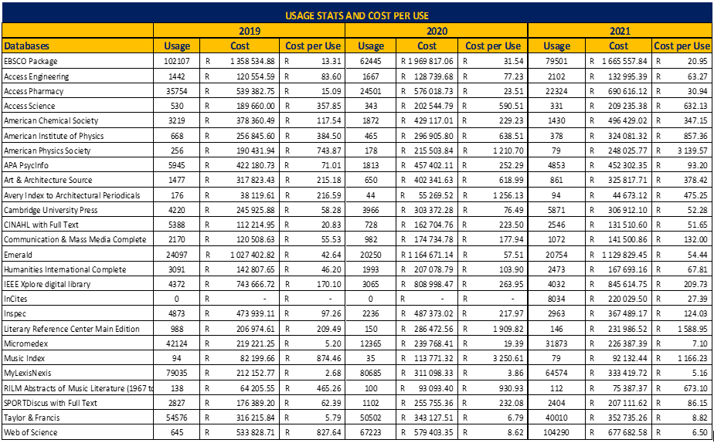

#### CATALOGUING SUB-DEPARTMENT:

#### PROJECTS:

1. Campus to campus visits for projects is still on hold due to COVID-19, and urgent wedding had to be shipped to South
2. Various database clean-up projects were conducted throughout the year to maintain international standard records for NMU libraries.

**INSTITUTIONAL REPOSITORY**

Our Institutional Repository currently has a total number of 6242 records and growing.

1. Pinnock, William's ***"To learn how to speak": a study of Jeremy Cronin's poetry*** is the most accessed thesis with 18115 hits, followed by:
2. Mtati, Nokuzola Julia's ***The impact of crime on the South African economic growth*** with 11391 hits and the third one being:
3. Makasana, Velile's ***The onus of proof and presumption of innocence in South African bail jurisprudence*** with 7201 hits.

**Three years comparison of the (VITAL) institutional repository usage -** [**http://vital.seals.ac.za:8080/vital/access/manager/Index?site_name=Nelson%20Mandela%20University**](http://vital.seals.ac.za:8080/vital/access/manager/Index?site_name=Nelson%20Mandela%20University)

|  |  |  |  |
| --- | --- | --- | --- |
| **STATS** | **2019** | **2020** | **2021** |
| **NMU IR Visitors**  The number of unique sessions created during this time period. | 7801 | 4645 | 7368 |
| **NMU IR Hits**  The total number of requests made to the repository. | 76568 | 39485 | 50232 |

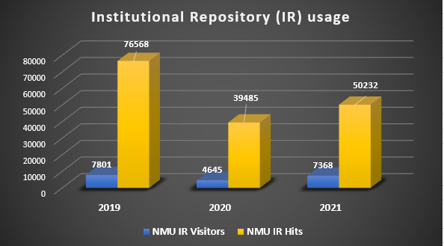

**Monthly comparison for year 2021**

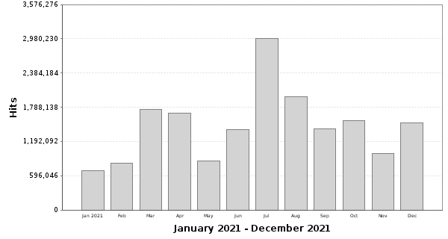

**PROCESSING STATISTICS**

Below are the statistics of 2021

**Cataloguing Statistics: Original and Cataloguing-in-Publication Data**

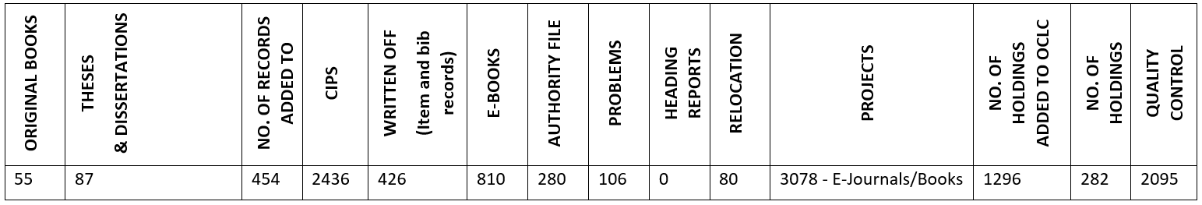

**Processing of items from Cataloguing**

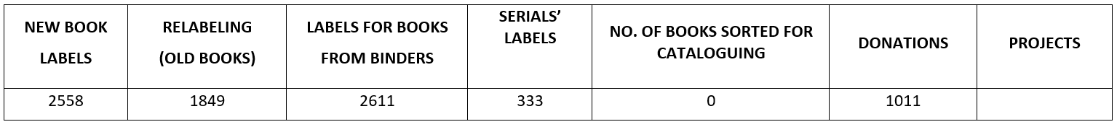

**Pre-Cataloguing and Classification**

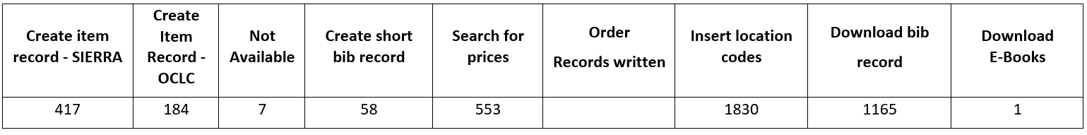

**YEAR COMPARISON TABLE (2018 – 2021)**

**MONOGRAPHS**

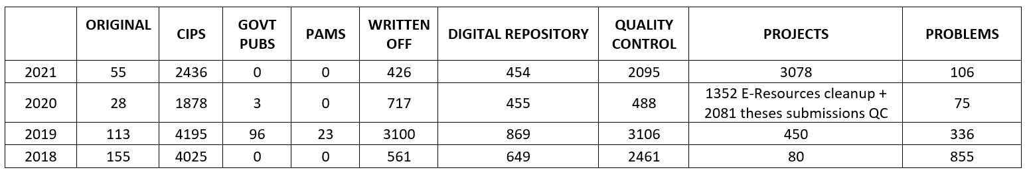

**MULTIMEDIA**

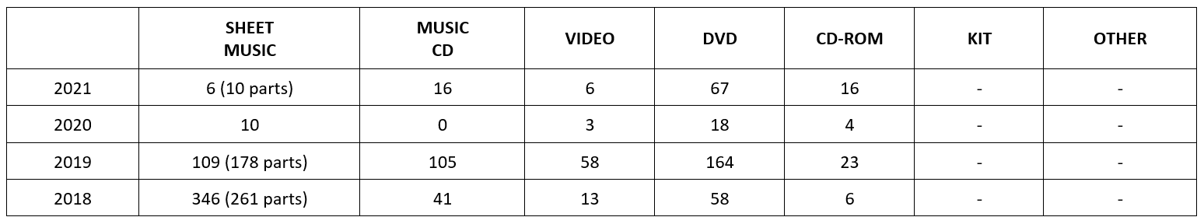

**SERIALS**

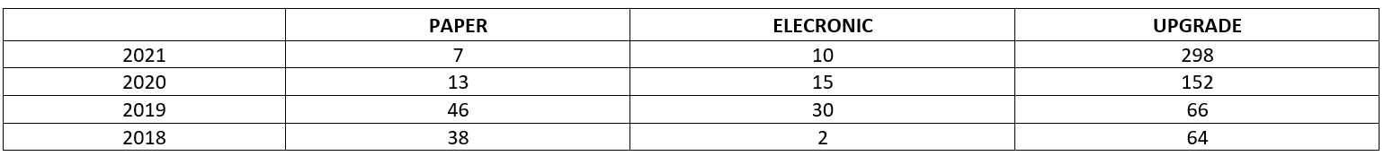

**Age of Collection as at 7 February 2022 reflected on SIERRA:**

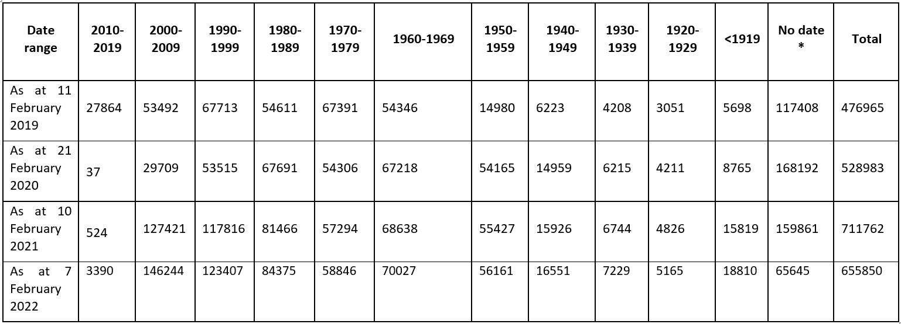

## Library and Information Systems and Digital Applications Department

**Library Website, Social Media platforms and Marketing:**

The Library Web Administrator maintains and updates all the pages and the many links on the Library website on an ongoing basis. This year saw the addition of "virtual cards" to the Website's Slideviewer option to promote the Faculty / Information Librarians' contact details. This was a successful addition to marketing Library services and was well-received. Library training and webinars were successfully promoted on the library's social media platforms and Library website on an ongoing basis throughout 2021.

**LIBRARY WEBPAGE:** [https://library.mandela.ac.za](https://library.mandela.ac.za/)

There has been a pleasing increase in the Library Website Home page views compared to 2020. The number of home page views for 2021 was 235 630, increasing from 211 504 in 2020.

**LIBRARY FACEBOOK STATISTICS**

The Total **Page LIKES** reflected a steady increase throughout the year:

**YouTube:**

The following recordings were added to the Library's YouTube channel during 2021:

|  |  |
| --- | --- |
| **MS Teams Library Training videos,** | **Library Starter Kit online training session,** |
| **Finding e-books on FindPlus** | **Ebscohost online training video** |
| **Finding information on your topic in FindPlus** | **NMU Virtual library video** |

**SYSTEMS AND NETWORKS:**

**Integrated Library System (Sierra):**

The Sierra software was upgraded several times during the year; the current version is 5.4.0_9. The SEALS Consortium signed up as a beta testing partner for this latest release before version 5.4 became available for general release. We were able to report back on various issues and software bugs found.

**Summon Discovery platform**:

The SEALS consortium acquired two new platforms in 2021, namely a new Library Discovery platform, Proquest/Ex Libris' **Summon**, and **ThirdIron LibKey**. The Discovery platform provides a single unified search across books, ebooks, journals, newspapers, videos, images, research guides and more from a single unified index of content pre-harvested and optimised for discovery. The platform uses a ranking algorithm to present balanced search results across content types, regardless of provider. Summon Discovery platform is not only specifically designed to promote the library's collections, but it is also designed to engage researchers and connect researchers to librarians and provide research guidance.

**LibKey:**

The addition of ThirdIron LibKey further facilitates one-click linking to the library's subscribed full-text articles. LibKey knowledge base is enriched with Unpaywall data to deliver Open Access versions when subscribed versions are unavailable.

A branded icon lets users know access to a full-text article comes via the library, as shown below:

**Support and Training:**

Throughout the year, the Systems Librarian provided ongoing support and training to LIS staff, for all modules, on a variety of issues. Creating various statistical reports in the different modules was one of the most frequent LIS staff requests for assistance. The Systems Librarian continued with increased support to the ERM module staff in 2021 by creating access check-in records for the single ebooks purchased and ongoing checking and problem-solving of database URLs and related access problems encountered.

**Annual Library survey**:

The **Annual Library survey** was again created after several years of being in abeyance. The survey title was **"The user experience of the Library's print and electronic resources"**. The Systems Librarian held meetings with senior Library staff to compile the survey questions and further submitted all the documentation required to apply for ethical clearance from the University to run the survey. The Web administrator set up the survey using the QuestionPro survey platform placed the survey link on the LIS website and marketed the survey on the library's social media platforms. Once the survey had closed, survey responses were collated for further action. The survey ran from 24 August 2021 to 29 September 2021. Of the 215 responses received, only 104 answered all the survey questions.

# **Library Financial Statements**

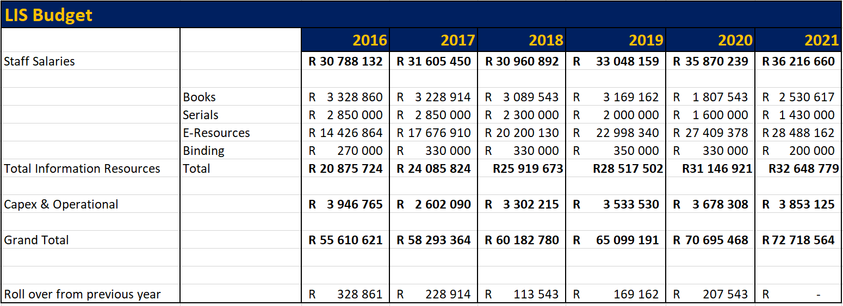

**CONCLUSION AND WAY FORWARD**

2021 was a challenging and stressful year as it brought about the fear of contracting the virus and adapting to the new normal. Despite it all, staff adopted and embraced a new way of working with the advancements in technology, making it possible to conduct our business. For LIS to go forward and achieve success, we will have to continue embracing change, implementing new services, stronger marketing of these services, and better communicating with our users. LIS V2030 strategic plan and goals we adopted in 2021 will enable us to become a 21st-century academic library that engages users where they learn, teach and do research.