OFF-CAMPUS ACCESS TO LIBRARY DATABASES

You can access most NMMU electronic databases with a PIN, created in the Library Catalogue.

1. HOW TO CREATE A PIN IN THE LIBRARY CATALOGUE

PLEASE NOTE:

You must be a registered library user (you are required to register every year) and must
have a current library barcode on the back of your student or staff card.

Go to the Library website at library.nmmu.ac.za
On the library website, click on
Proceed as follows:
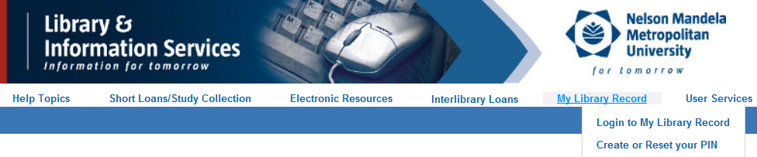
Click on Login to My Library Record link.

On the next screen, complete only the first two text boxes.
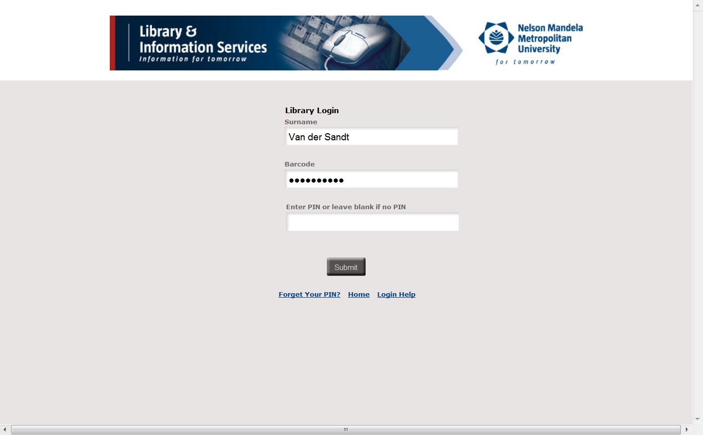
Leave the text box for the PIN blank.
Type your surname in the first text box.
Type your library barcode (the no. at the back of your student/staff card) in the next text box.

On the next screen, you can enter a PIN.
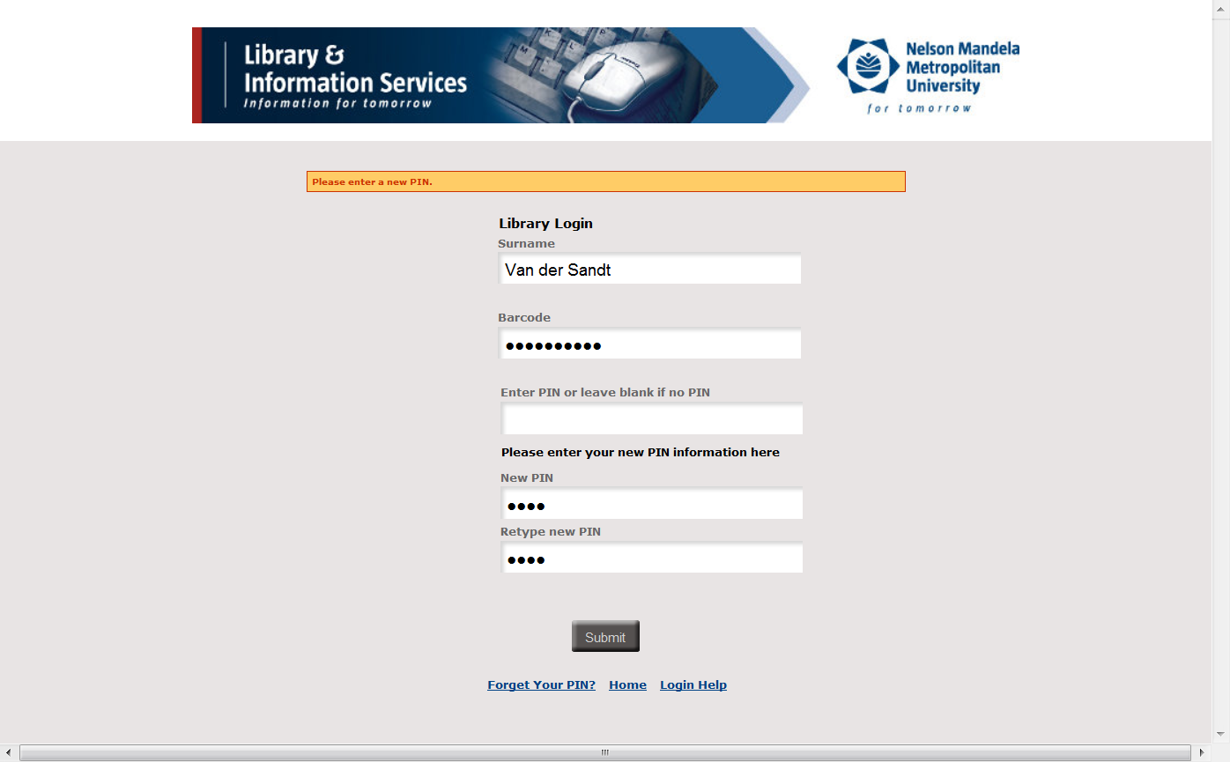
Once you have entered a PIN and confirmed it by entering it again, click on Submit.
Choose your own PIN: it can be a word or numbers or combination, not longer than 8 characters
Leave this text box blank.
Type your surname in the first text box.
Type your library barcode (the no. at the back of your student/staff card) in the next text box.

The next screen will show your Library record. You can now click on at the top of the screen.
The next section explains how to use the PIN, created in the Library Catalogue, to access Databases off-campus.

2. OFF-CAMPUS ACCESS WITH A PIN CREATED IN THE LIBRARY CATALOGUE

Go to the Library website at library.nmmu.ac.za

On the library website, click on

You can now search any of the databases by clicking on the off-campus link under the database title.

The next screen will ask you to verify yourself.

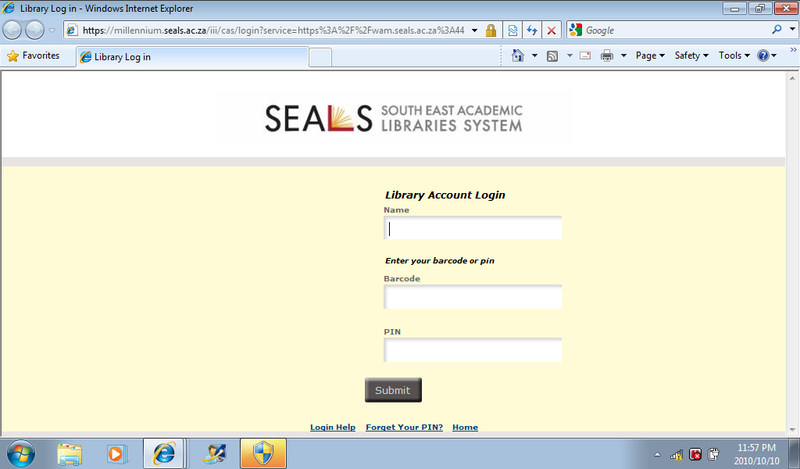

- Enter your personal details and PIN number (created as instructed under § 1).
- Click on Submit.
The home page of your chosen database will display.

